Security in Computing Practical 6
Configuring a Zone-Based Policy Firewall (ZPF)
Practical 6:- Configuring a Zone-Based Policy Firewall (ZPF)

Topology:
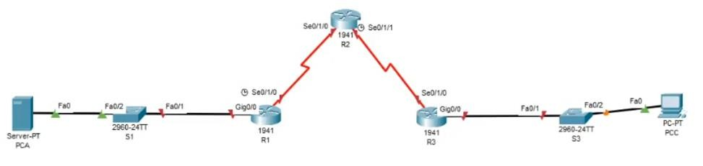

Router R1 Configuration
enable
conf t
hostname R1
enable secret enpa55
line console 0
password conpa55
login
exit
line vty 0 4
password vtypa55
login
exit
ip domain-name ccnasecurity.com
username admin secret adminpa55
line vty 0 4
login local
transport input ssh
exit
crypto key generate rsa
1024
interface g0/0
ip address 192.168.1.1 255.255.255.0
no shutdown
exit
interface s0/1/0
ip address 10.1.1.1 255.255.255.252
clock rate 64000
no shutdown
exit
ip route 192.168.3.0 255.255.255.0 10.1.1.2
end
wr

Router R2 Configuration
enable
conf t
hostname R2
enable secret enpa55
line console 0
password conpa55
login
exit
line vty 0 4
password vtypa55
login
exit
ip domain-name ccnasecurity.com
username admin secret adminpa55
line vty 0 4
login local
transport input ssh
exit
crypto key generate rsa
1024
interface s0/1/0
ip address 10.1.1.2 255.255.255.252
no shutdown
exit
interface s0/1/1
ip address 10.2.2.2 255.255.255.252
clock rate 64000
no shutdown
exit
! Static routes (IMPORTANT - your missing part added)
ip route 192.168.1.0 255.255.255.0 10.1.1.1
ip route 192.168.3.0 255.255.255.0 10.2.2.1
end
wr

Router R3 Configuration (ZPF Firewall)
enable
conf t
hostname R3
enable secret enpa55
line console 0
password conpa55
login
exit
line vty 0 4
password vtypa55
login
exit
ip domain-name ccnasecurity.com
username admin secret adminpa55
line vty 0 4
login local
transport input ssh
exit
crypto key generate rsa
1024
interface g0/0
ip address 192.168.3.1 255.255.255.0
no shutdown
exit
interface s0/1/0
ip address 10.2.2.1 255.255.255.252
no shutdown
exit
! ZONES
zone security IN-ZONE
zone security OUT-ZONE
! ACL for internal traffic
access-list 101 permit ip 192.168.3.0 0.0.0.255 any
! CLASS MAP
class-map type inspect match-all IN-NET-CLASS-MAP
match access-group 101
! POLICY MAP
policy-map type inspect IN-2-OUT-PMAP
class type inspect IN-NET-CLASS-MAP
inspect
! ZONE PAIR
zone-pair security IN-2-OUT-ZPAIR source IN-ZONE destination OUT-ZONE
service-policy type inspect IN-2-OUT-PMAP
! ASSIGN INTERFACES
interface g0/0
zone-member security IN-ZONE
exit
interface s0/1/0
zone-member security OUT-ZONE
exit
ip route 192.168.1.0 255.255.255.0 10.2.2.2
end
wr

Verification Steps
1. show ip interface brief
2. show ip route
3. show policy-map type inspect zone-pair sessions
4. Test:
PC-C → PC-A (Ping, SSH, HTTP) → Allowed
PC-A → PC-C → Blocked
5. SSH Test:
ssh -l admin 10.2.2.2
6. Web Test:
http://192.168.1.3

Practical 6: Zone-Based Policy Firewall (ZPF)
- On R3 (Firewall Router):
  - show policy-map type inspect zone-pair sessions: To see active "inspect" sessions created by internal traffic.
  - show zone security: To verify the IN-ZONE and OUT-ZONE memberships.
  - show class-map type inspect: To see the traffic matching criteria (ACL 101).
- Test Connectivity:
  - From PC-C (Inside): Ping/SSH to PC-A (Outside) should work.
  - From PC-A (Outside): Ping to PC-C (Inside) should be blocked by default.

Practical 6: Zone-Based Policy Firewall (ZPF)
On Router R3
- Inspect Sessions: While PC-C is pinging or using SSH to R2, run show policy-map type inspect zone-pair sessions. It should show an active session.
On PC-A (Outside Zone)
- Inbound Block: Run ping 192.168.3.3 (should time out because traffic from OUT-ZONE to IN-ZONE is not permitted).

Viva Questions
1. What is ZPF?
Zone-Based Policy Firewall is used to control traffic between zones.
2. What is Zone?
Logical grouping of interfaces.
3. What is Class-map?
Defines traffic.
4. What is Policy-map?
Defines action (inspect, drop, pass).
5. Why ZPF?
More secure than ACL.

